Final Paper

Group 1

October 11, 2023

Group Members:

Nolan Coetzee, Yusufu Weinila, Brianna Gilbert,

Mazin Bakhit, and Natalie Ramdeo

**Section 1:**

Company Analysis

1. Description of the Firm;

* Company History
  + 2 CAR T (Autologous Chimeric antigen receptor C Cell Theory) therapies were FDA-approved in 2017. Allogene’s goal is to turn the historically personalized CAR T into a massively produced therapy using T cells from healthy patients in order to create “off the shelf” inventory. This will result in more patients being treated more quickly (Allogene Therapeutics 2023) .
* Products
  + Some of their products include a pipeline that’s made of off-the-shell T cell products. These are specifically designed to target and kill the cancer cells.
  + The company’s approach is sorted into 4 pillars. Those include the following;
    1. Developing product candidates to minimize the risk of graft-vs-host-disease (GvHD), which is a condition where allogenic T cells can recognize the patient’s normal tissue as foreign and cause damage.
* Firm Scope
  + The company is located in San Francisco, California.
  + The target customer base includes people who are looking for a form of cancer treatment for either themselves or a loved one.
  + The technology used in Allogeneic Therapeutics can vary, but one of the major technologies that they use includes pipelines that are used to target and kill cancer cells.
* Firm Size
  + Total Assets
    1. 2018: 773,855
    2. 2019: 717,802
    3. 2020: 1,227,829
    4. 2021: 1,038,634
  + Total Sales:
    1. 2018: -211,199
    2. 2019: -184,594
    3. 2020: -250,211
    4. 2021: -257,00
  + Number of Employees
    1. As of the year 2021, Allogene Therapeutics currently has at least 310 employees working for their company. Out of that number, 308 are full-time. From that set of full-time employees, only 70 of them hold either Ph. Ds or M.D degrees. And from the 310 employees, only 234 of them are engaged in the research side of the company (Allogene Therapeutics 2023).

**2. Financial Performance:**

Formulas included:

* RETURN ON SALES Operating profit/ revenue * 100
* RETURN ON ASSETS Net Income/ Total Assets *100
* RETURN ON EQUITY Net Income /Shareholder equity Return
* CURRENT RATIO Current Assets/ Current Liabilities
* QUICK RATIO (Cash + Accounts Receivable) / Current Liabilities

Financials (2018-2021):

Allogene:

* Return on Assets: -24.53%
* Return on Equity: -27.65%
* Operating Profit Margin: -1276.79%
* Current Ratio: 1277.32%
* Debt to Assets: 11.34%
* Debt to Equity: 12.81%

Industry Average:

* Return on Assets: -12.25%
* Return on Equity: -17.25%
* Operating Profit Margin: -46.00%
* Current Ratio: 522.50%
* Debt to Assets: 31.75%
* Debt to Equity: 46.50%

In 2018 Allogene bolstered their business through a private financing venture in September that made them 120.2 million dollars. A month later in October, Allogene IPO raised 372.6 million in gross proceeds. Regardless of this mass amount of funds, Allogene had a worse ROA, and ROE compared to the industry average. This is a theme that was carried out throughout the following three years. The graph below shows the comparison of Allogene’s ROA, and ROE to the industry average.

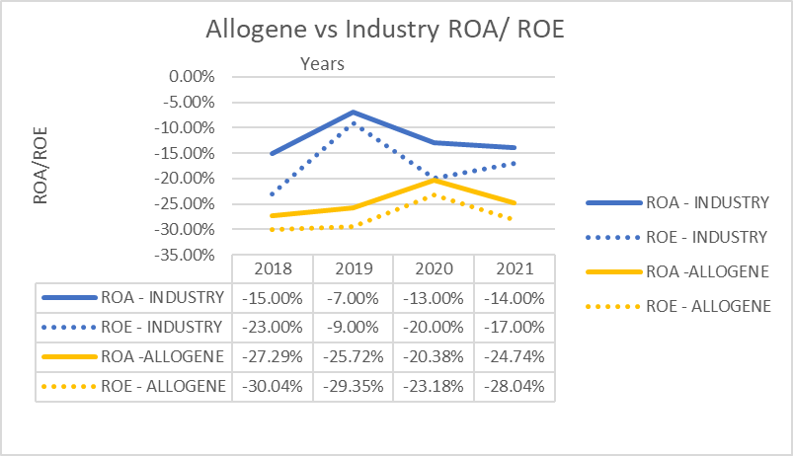

As Allogene is a newer company that is studying a new medicine, Allogene might suffer from lower profitability because companies that are in early-stage development of their product spend most of their resources on research and development. Their product is also pending regulatory approval which means they won't generate money through sales, rather they must raise money. These are two reasons why the ROA and ROE of this new company are lower than the industry average. Allogene’s lack of revenue through sales also explains their drastically low operating profit margin. Allogene’s operating profit and net profit margins were identical and followed a similar trend. When Covid-19 hit in 2020, there was a drastic decrease in revenue like every other business. Their revenue went from $85,694 in 2019 to $13,375 in 2020 while their operating profit decreased from -$184,594 in 2019 to -$250,211. The graph below shows the drastic percentage decrease in operating profit from pre-Covid to during Covid.

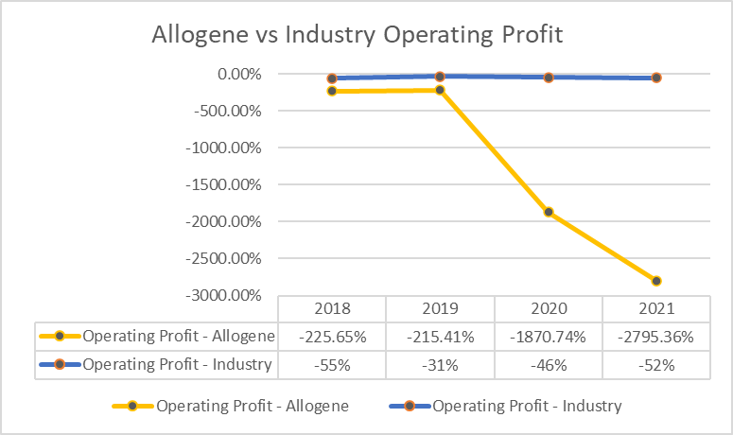

Allogene’s current ratio is better than the industry average. This is due to large funding they receive and the amount of cash, equipment, and resources they have on hand. Their current assets were larger than Allokos, Aptinyx, Gristone, Surface Oncology, and Y-mAbs for all four years. Their current liabilities were also larger, however only by a small margin. This means that Allogene may have adopted a conservative approach to cash management, to ensure liquidity in their business. Below shows Alloegene’s current ratio compared to the industry average.

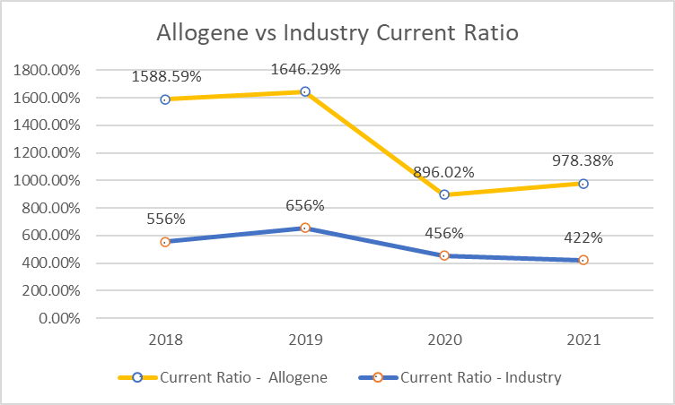

Allogene has raised hundreds of millions of dollars to aid the development of allogeneic CAR T cell products. Investors believe that if this newer technology can cure cancer like they hope then the investor will make large returns. However, without the regulatory approval from the FDA, this company has stayed small and invested most of their money in research and development. They only have 3 locations, 5 clinical candidates and 13 preclinical targets, meaning their investments have been relatively small. With the heavy funding and low investments, Allogene boasts a better Debt to Asset ratio and Debt to Equity ratio than the industry average.

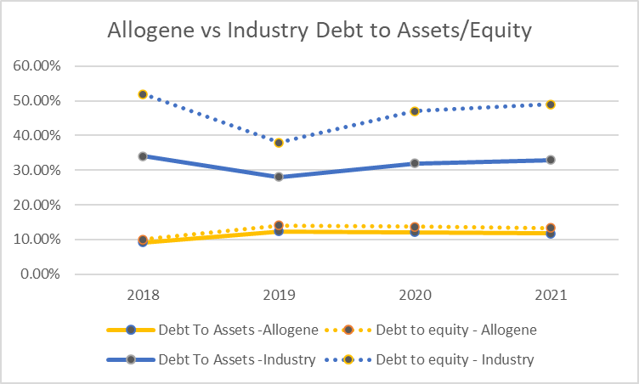

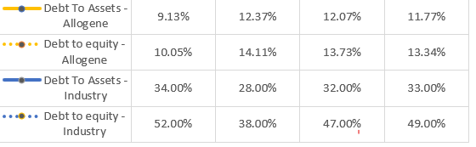

Overall, Allogene Therapeutics is financially sound due to large amounts of investments from outside investors who believe in the new cancer treatment. They can cope with their drastically low ROA and ROE because they have an enormous amount of current assets with more funds that will definitely come in. Their operating profit margins are low due to their service not being permitted yet. In due time, when the service is approved, this percentage will begin to trend toward the industry average. The Current Ratio is better than the industry average because of their heavy sources of funding and their small number of investments. The vast amount of funding also plays a part in both their debt to asset ratio and debt to equity ratio where their fundraising has made their percentages better than the industry average.

**3. Tangible and Intangible Resources (Chapter 3):**

In terms of tangible and intangible resources, Allogene Therapeutics mainly focuses on having intangible assets as opposed to having both tangible and intangible resources. The biggest reason is that this company focuses on the development and commercialization of genetically engineered allogeneic T cell therapies for the treatment of cancer. As a result of that, there are costs for the intangible assets used, and as for the tangible assets, there’s no information about any tangible resources within Allogene Therapeutics (Allogene Therapeutics 2023).

Their intangible assets consist of in-process research and development and workforce associated with the Pfizer asset acquisition. Acquired intangible assets are currently expensed as research and development costs as long as the technology is under development. It can also be expensed if it’s not approved by the FDA or other regulatory agencies and has not reached technical feasibility (Allogene Therapeutics 2023).

Intangible assets

|  |  |  |  |
| --- | --- | --- | --- |
| 2018 | 2019 | 2020 | 2021 |
| $23,086 | $22,770 | $20,582 | $14,648 |

According to the table above, 2018 was the highest, but as the years went by, there was a slow decline in the costs of these intangible assets. But when 2021 came around, Allogene Therapeutics had a massive drop, going down to 14,648. When you examine the numbers from 2018 and 2021 and subtract them, it shows that the drop was insanely massive, reaching a number of 8,438.

Allogene Therapeutics’s resources can include various things, but one of their notable resources is a pipeline containing allogeneic T-cell product candidates (Allogene Therapeutics 2023). These are designed to target and kill cancer cells. The company’s engineered T cells are allogenic, which means that they are derived from specific healthy donors to be used in any patient.

The pipeline the company is developing contains multiple allogeneic CAR T cell product candidates utilizing the following;

* Protein Engineering
* Gene Editing
* Gene insertion
* Advanced proprietary T cell manufacturing technologies

The firm does have a competitive advantage since their focus is more towards the treatment of cancer and the research/development behind that. The biggest reason Allogene Therapeutics has this competitive advantage is because they are seen more as a research/development facility rather than a company looking for profits. In other words, they have various ways of making money. One of the biggest ways Allogene Therapeutics can make money is by capturing the attention of different people and different companies. The reason for this is that if these companies/people develop an interest in what this company is doing, then they might choose to invest their time and money to do further research within this company.

Some people may claim that them being more of a research company may put them at a competitive disadvantage rather than an advantage, but as stated above, it’s clear that them being a research/development company will give them a massive advantage since they strive to help treat cancer.

**4. Current Strategy:**

As a startup firm attempting to bring a new biotech product into the market, Allogene Therapeutics has a focused differentiation business strategy. They have created and intend to maintain their first mover advantage in CAR T to provide the most value for their customers and keep their competitive advantage. This will ensure that Allogene Therapeutics grows and will continue having further opportunities to grow.

Due to the company’s hyperfocus on the development of CAR T it has a low level of diversification. This doesn’t allow for much of a corporate strategy as Allogene is more a part of other institutions corporate strategy rather than other companies being a part of Allogene’s corporate strategy. Seeing as they don’t operate at a profit, it doesn’t seem very possible that they would be able to create or purchase an additional company, however it is worth considering options once they do become profitable. Allogene Therapeutics is heavily reliant upon its partner Cellectis to maintain its business. Acquiring this business or creating a competitor may be a sound business strategy for later in Allogene’s lifetime.

Allogene Therapeutics is aware and prepared for the hurdles that come with distributing medicinal products abroad. Just as the FDA exists in the United States, other countries have similar agencies with their own vetting process that products must pass before they are available commercially. Currently, the focus is on the United States and the EU, as they have similar vetting processes. However, distribution in the EU also involves respecting the General Data Protection Regulation. Violation of this regulation could involve massive fines of up to 20 million dollars. The processes involved in getting CAR T approved in other nations such as those in Eastern Europe, Asia, and Latin America have wildly varying requirements. As a result, we suggest first getting FDA approval, while being mindful of the requirements of other nations. Then moving towards the EU before expanding into other nations on a nation by nation basis.

**5. Cooperative Strategy (Chapter 9):**

Out of all the major structures, the Joint Venture is the one that fits the best with the company. Our joint venture with Overland Pharmaceuticals or the development, manufacturing, and commercialization of certain of our product candidates targeting BCMA, CD70, FLT3, and DLL3 in China, Taiwan, South Korea and Singapore. In 2021, we hired a new chief executive officer, leased a facility for manufacturing and began technology transfer for manufacturing.

* Manufacturing at our manufacturing facility, advanced our innovative research, expanded our board of directors and scientific advisory board, and progressed our joint venture in China, each as further described in the summary of our executive
* compensation disclosure contained in this proxy statement.
* Equity strategic alliance
* for the purpose of developing, manufacturing and commercializing allogeneic CAR T cell therapies for patients in greater China, Taiwan, South Korea and Singapore.
* Licensing from Pfizer
* Non-equity Strategic Alliance

Allogene Therapeutics has a few allies in the industry. 15% of the company is owned by Pfizer, a biopharmaceutical company. 13% is owned by TPG GP A LLC, a company focused in asset management. Alongside these allies, Allogene has a joint venture with Overland Pharmaceutical for the purpose of developing, manufacturing, and commercializing allogeneic CAR T cell therapies for patients in greater China, Taiwan, South Korea, and Singapore.

A Research Collaboration and License Agreement with Cellectis S.A., an Exclusive License and Collaboration Agreement with Les Laboratoires Servier SAS and Institut de Recherches Internationales Servier SAS (collectively, “Servier”), and other intellectual property for the development and administration of CAR T cells for the treatment of cancer were among the assets and liabilities the company acquired from Pfizer. This is known as an Equity strategic alliance because Pfizer took an ownership stake in Allogene Therapeutics

**6. Internal Governance Mechanisms at Allogene Therapeutics:**

**Ownership Concentration**

In the realm of corporate governance, ownership concentration plays a pivotal role for companies like Allogene Therapeutics, a biotechnology firm. Understanding the distribution of ownership is crucial since it directly impacts decision-making. As a publicly traded company, Allogene's ownership is diffused among numerous shareholders. Data from Morningstar (2023) suggest that the company is largely owned by institutional owners. In fact, the company has 400 intuitional owners, who control 68% of the company. The largest shareholders, according to Morningstar (2023), include FMR Inc. (14.87%), TPG GP A, LLC (11.17%), State Street Corporation (5.06%), and BlackRock Inc. (5.04%). The ownership concentration is summarized in table 1 below.

*Table 1: Allogene Therapeutics’ ownership structure*

|  |  |
| --- | --- |
| Shareholder type | Percent |
| Institutions | 68.09% |
| Private companies | 0.01% |
| Individual insiders | 8.20% |
| Public companies | 12.80% |
| VC/PE firms | 10.90% |
| Total | 100.00% |

Table 1 shows that Allogene Therapeutics, as a customer for publicly traded biotech companies, exhibits a dispersed ownership structure. This carries both advantages and challenges. On one hand, it mitigates the risk of a single entity wielding excessive control. On the other, it can render shareholders less influential in shaping strategic choices. In such scenarios, institutional investors often assume a significant role in upholding corporate governance. In fact, Hill et al. (2019) suggest that share ownership by large-block shareholders is an effective mechanism for ensuring effective government since the shareholders demand and ensure that firms adopt sound governance strategies. As such, having institutional investors hold a large percentage of Allogene Therapeutics’ shares is an effective strategy that potentially ensures effective corporate governance.

**Board of Directors**

The board of directors constitutes a pivotal internal governance mechanism that acts as a custodian of shareholder interests. The board's composition, independence, and effectiveness are paramount considerations. Ideally, the board should provide oversight and strategic guidance to the company's executives. A balanced mix of independent and non-executive directors is essential to impartially assess management's performance. The number of board members, their qualifications, and their dedication to shareholder interests are pivotal factors. Allogene Therapeutics' board of directors comprise healthcare investors, academics, biotech entrepreneurs, and pharma industry veterans, who, according to the company, have extensive expertise in gene and cell therapy. The board's membership is summarized in Table 2 below.

*Table 2: Allogene Therapeutics Board Membership (Reuters, 2023).*

|  |  |
| --- | --- |
| Member | Position |
| Arie Belldegrum | Executive chair |
| David Bonderman | Chairman, lead independent director |
| David Chang | President, CEO, and member |
| Timothy L. Moore | Executive vice president |
| Deborah M. Messemer | Independent director |
| Franz B. Humer | CEO, Roche Holdings Ltd |
| John DeYoung | Independent director |
| Joshua Kazan | Director |
| Elizabeth Barret | Independent director |
| Owen Witte | Independent director |
| Stephen Mayo | Independent director |
| Todd Sisttsky | Independent director |
| Vicki Sato | Independent director |

From Table 2, we see that Allogene Therapeutics observes the principle of separation. In fact, the positions of executive chair and chief executive officers are separate, a principle that reinforces board independence in its oversight function. The board comprises both independent (outsiders) and executive directors (insiders), a factor that is essential to ensuring corporate credibility and improving corporate governance, according to Hill et al. (2019). The board, as indicated on the company’s website, includes people with diverse backgrounds. This fact, as noted by Hill et al. (2019), is critical to ensuring the effectiveness of the board of directors.

**Executive Compensation**

Executive compensation stands as a critical facet of corporate governance. It should harmonize with the company's performance and the interests of shareholders while sidestepping excessive pay that does not correlate with performance. Compensation packages typically encompass a blend of elements, including base salary, performance-linked bonuses, stock options, and other contingent compensation components. Concerning Allogene Therapeutics, the company’s executive compensation is based on performance and linked to the company's long-term strategic plan of creating sustainable shareholder value (Allogene Therapeutics, 2022). The compensation includes base salary, equity incentive awards, and annual performance-based cash incentives. Figure 1 depicts the company's executive compensation mix.

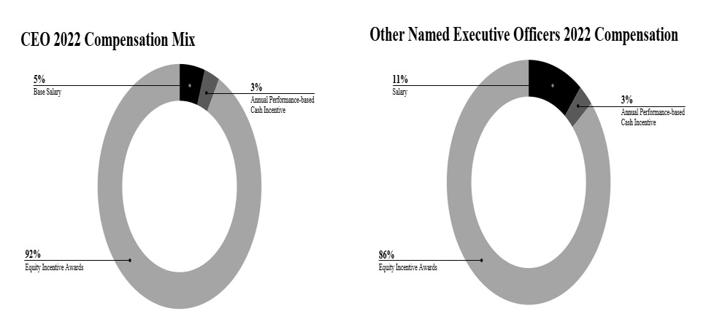

Figure 1: Compensation mix (Allogene Therapeutics, 2023)

Based on information in Table 3, it appears that Allogene Therapeutics' executives are fairly compensated. The CEO, David Chang, received $14.80 million in 2022, an amount that aligns with the average of $15 million paid to top CEOs in the US (Bivens & Kandra, 2022). The CEO pay, as noted in Table 3, is higher than that of other executives, suggesting that executive compensation is provided based on the value provided to the organization. In addition, the executive compensation package seems to be in line with industry norms. In fact, as is the industry norm, the executive compensation at Allogene Therapeutics is structured to be performance-driven, adhering to principles of sound corporate governance. Elements like base salaries and annual cash bonuses are designed to recognize executives for their contributions to the company's achievements. This approach ensures that their compensation is directly correlated with their performance, reflecting the company's dedication to rewarding merit. The company executives are granted equity awards in the form of options to acquire company shares and RSU awards. These equity incentives promote a long-term perspective on compensation, aligning the interests of executives with those of shareholders. This framework incentivizes executives to focus on sustainable growth and value creation, as their financial well-being is interconnected with the company's long-term success.

From the preceding analysis, we see that Allogene Therapeutics has a sound corporate governance structure. In fact, the company has implemented the necessary mechanisms critical to ensuring effective governance. For example, the company's board comprises members from diverse backgrounds, a key factor that Hill et al. (2019) suggest would enhance board effectiveness. The company's shares are owned majorly by institutional investors (68%), suggesting that instances of executive opportunism are unlikely. In fact, according to Hill et al. (2019), institutional investors have the incentive and size to discipline ineffective executives to ensure their firms' strategies align with their interests. In summary, Allogene Therapeutics has implemented vital principles that are necessary to ensure good corporate governance. We can thus conclude that the company has a good corporate governance that is capable of protecting shareholders from executive opportunism.

**7. Strategic Leadership:**

Evaluating the diversity within Allogene Therapeutics' top management team is essential for comprehending the composition of leadership within the organization. Heterogeneity within top management encompasses aspects such as experience, education, and professional background, all of which can significantly influence the company's strategic decision-making and overall prosperity. Table 4 summarizes the key aspects of Allogene Therapeutics’ top management team. It depicts the five named executive officers as of December 30, 2022.

Table 4: Allogene Therapeutics’ named executive officers (Allogene Therapeutics, 2023)

|  |  |  |  |  |  |
| --- | --- | --- | --- | --- | --- |
| Name | Position | Gender | Age | Experience | Education |
| David Chang | President, CEO | Male | 63 | Extensive experience in biopharmaceuticals | MD from Stanford University School of Medicine, BA in Biochemistry from Harvard University |
| Eric Schmidt | Chief Operating Officer | Male | 54 | Vast experience in biotechnology and operations | Ph.D. in Chemical Engineering from Stanford University, BS in Chemical Engineering from UC Berkeley |
| Rafael Amado, MD. | Executive Vice President | Male | 59 | Extensive experience in clinical development | MD from Free University of Brussels, Belgium |
| Alison Moore, Ph.D. | Executive Vice President | Female | 56 | Expertise in clinical research and development | Ph.D. in Molecular and Cellular Biology from the University of Cambridge, M.A. in Natural Sciences from the University of Cambridge |
| Veer Bhavnagri | Chief Financial Officer | Male | 40 | Wide-ranging experience in finance and operations | MS in Engineering-Economic Systems from Stanford University, MBA from Stanford Graduate School of Business, MS in Mechanical Engineering and BS in Engineering and Applied Science from California Institute of Technology |

From Table 4, we see that the top management team at Allogene Therapeutics exhibits heterogeneity concerning expertise, encompassing both male and female executives. This diversity allows members to bring forth their unique experiences and perspectives, enriching the organization's leadership. According to Hill et al. (2019), heterogeneity in top management is essential for various reasons, including:

* **Innovation and Creativity:** Diverse management teams tend to foster innovation and creativity. Varied perspectives can lead to more innovative solutions to complex issues, a valuable trait in the biotechnology industry where innovation is a primary driver of success.
* **Risk Management**: A diverse top management team is better equipped to assess and manage risks from multiple angles. Different experiences and backgrounds contribute to a more comprehensive understanding of potential risks and more effective risk mitigation strategies.
* **Market Responsiveness:** Diverse leadership can help Allogene Therapeutics respond more effectively to a dynamic market landscape. Adaptation to market shifts is crucial in the highly dynamic biotechnology sector.
* **Global Perspective:** Heterogeneous teams often bring a global perspective to decision-making, which is advantageous for a company like Allogene Therapeutics operating in a global market. It enables the organization to navigate the intricacies of international business effectively.
* **Ethical Decision-Making:** Diverse teams can lead to more ethical decision-making. Various backgrounds and perspectives encourage ethical discussions and considerations, ensuring that ethical standards are upheld in all aspects of the company's operations.

In summary, the varied composition of Allogene Therapeutics' top management team, encompassing diversity in experience and professional backgrounds, significantly contributes to enhancing the company's strategic capacities. This diversity fosters innovation, improves risk management, enhances market adaptability, provides a global outlook, and encourages ethical decision-making, all of which are imperative for prospering in the fiercely competitive biotechnology sector. By harnessing the diverse experiences and perspectives of its top management team, Allogene Therapeutics is well-positioned to advance its mission of pioneering innovative cellular immunotherapies for cancer treatment, ultimately leading to improved patient outcomes.

**8. Strategic Entrepreneurship:**

Allogene Therapeutics, a pioneering biotechnology company focused on developing allogeneic CAR T therapies for cancer treatment, showcases a substantial entrepreneurial spirit and actively pursues entrepreneurial opportunities, although it does not explicitly use the term "entrepreneurial opportunities" in its communications. One key example of the company’s entrepreneurial approach can be observed in its commitment to advancing CAR T cell therapies. In the biotechnology and healthcare sector, creating novel and innovative therapies represents a substantial entrepreneurial endeavor. Allogene's emphasis on developing allogeneic CAR T cell therapies on its website demonstrates its recognition of entrepreneurial opportunities within the healthcare and biotech industries. The company, according to information presented on its website, is dedicated to addressing unmet medical needs through groundbreaking treatments, positioning itself as an entrepreneurial leader in the field (Allogene Therapeutics, 2023).

Allogene's pursuit of strategic collaborations and partnerships with various organizations is another strong indicator of its entrepreneurial orientation. These partnerships encompass academic institutions, pharmaceutical companies, and research centers (Allogene Therapeutics, 2023). This collaborative approach reflects the network-centric aspect of entrepreneurship discussed by Hill et al. (2019) in chapter 13. Allogene understands that by collaborating with various stakeholders, it can explore new pathways for research, development, and commercialization. This cooperative spirit underlines the company's proactive approach to leveraging entrepreneurial opportunities within the life sciences ecosystem. In the biotechnology industry, entrepreneurial ventures often involve taking calculated risks due to the inherent uncertainty associated with innovative projects. Allogene has shown its willingness to invest in the development of allogeneic CAR T cell therapies despite the substantial risks involved. This risk-taking behavior is in alignment with the entrepreneurial mindset described by Hill et al. (2019). It signifies that the company’s management team embraces the inherent uncertainty and challenges associated with pioneering medical innovations.

While Allogene demonstrates an entrepreneurial approach in various aspects of its operations, it is also essential to consider the regulatory environment within which the company operates. The healthcare and biotech sectors are subject to strict regulatory requirements, which can influence the speed and flexibility of entrepreneurial decision-making. Compliance with these regulations is non-negotiable, and it may impact the agility and risk-taking behavior commonly associated with entrepreneurship. However, Allogene manages to navigate this delicate balance between regulatory compliance and entrepreneurial ambition. The management's role is pivotal in shaping the company's entrepreneurial mindset. The experience, background, and approach of the leadership team significantly influence the company's overall culture. Although the 2022 annual report and press releases do not explicitly detail the management team's mindset, it is reasonable to infer that the company's strategic direction and emphasis on innovation and risk-taking align with an entrepreneurial approach. This alignment is further supported by the leadership's extensive experience in the biotech and healthcare sectors, as evident from their profiles on Allogene's official website.

While Allogene Therapeutics may not explicitly use the term "entrepreneurial opportunities" in its communications, it actively pursues such opportunities in its actions and strategies. The commitment to advancing allogeneic CAR T cell therapies, its network-centric approach through collaborations, and its willingness to embrace risk and uncertainty in the biotechnology sector all reflect a strong entrepreneurial orientation. The company effectively balances regulatory compliance with a proactive and innovative mindset. The leadership team's extensive industry experience reinforces the notion that Allogene is indeed an entrepreneurial player in the biotech landscape.

**Section 2**

**Industry Analysis**

**General Environment:**

General environment forces have many types of forces, which include demographic, economic, political/legal, sociocultural, technological, global, and finally, sustainable physical environment. Each of these forces has great influence over Allogene Therapeutics given the industry that they are in.

For demographics, Allogene Therapeutics gathers data from people of all types, and then they would take that information to see which groups are most affected and which are not. When they have that information, they can begin treatment for the group of people that have been affected the most. In terms of income distribution within Allogene Therapeutics, their pay is as far as they stated that they believe in equal pay (Allogene Therapeutics 2023). This means that they believe that no one should be paid more than another person or less than another person.

For economics, Allogene Therapeutics depends greatly on many of its license agreements with companies like Pfizer, Servier, and finally, Cellectis. Each of these companies brings something that’s beneficial to the company. If Allogene Therapeutics didn’t have these agreements with these types of companies, then there's a chance that they would not be in the place that they are now.

For political/legal, Allogene Therapeutics depends on their license on Servier in-licensing, which is directly from Cellectis. Disputes may occur between these companies and the licensors when it comes to regards to intellectual property. Those include things like the scope of rights granted under the license agreement, whether and the extent to which the technology and processes infringe on the intellectual property of the licensor, the right to sublicense patents and other rights to third parties, diligence with respect to the use of the licensed technology, and finally, the ownership of inventions and know-how, which would result from the joint creation or the use of intellectual property from Allogene Therapeutics’s licensors.

For sociocultural, Allogene Therapeutics is known to be very diverse when it comes to the people who work there. They are committed to cultivating, fostering, and preserving a culture of diversity, equity, and inclusion. For their work environment, they strive to have a wide range of people from all different backgrounds. They reportedly have 50% of women working for them. In terms of their Director-level employees, roughly 45% of them are women. In addition to this, 66% of all of their employees were self-ethnic or part of racial minorities in the United States.

For technology, Allogene Therapeutics uses gene-editing technology as a way to help produce their engineered T cells. They specifically get their technology from a place called Cellectis. Without the partnership that these two companies have, it would be much harder for Allogene Therapeutics to produce their engineered T-cells.

For the global segment, Allogene Therapeutics’s business grew significantly when the 2020 COVID global pandemic hit. That includes their preclinical studies and clinical trials. However, there also have been some downfalls with this. For one, Allogene Therapeutics had to halt or even suspend enrollment for their clinical trials. Depending on the number of people they already had for the clinical trials, it’s safe to assume that their results may not be any different than what it already was. They also had to delay enrolling and retaining in their clinical trials. As previously stated, if the number of people they already had in their clinical trials did not change much, then their results would be nearly identical to any previous results.

Another major issue that Allogene Therapeutics had due to the global pandemic was the increased rates of patients withdrawing from their clinical trials due to COVID-19-related infections. Because of those infections, the patients who withdrew were

For the sustainable physical environment segment, Allogene Therapeutics regularly review their system of internal control over things like financial reporting as well as make changes to their processes and systems to improve controls and increase efficiency. At the same time, they are ensuring that they maintain an effective internal control environment.

The FCPA (Foreign Corrupt Practices Act) prohibits any US individual or business from paying or offering anything of value, directly or indirectly, to any foreign official, political party, or candidate for the purpose of influencing any act or decision of the foreign entity to assist the individual or business in obtaining or retaining business. The FCPA also obligates companies whose securities are listed in the US to comply with accounting provisions requiring the company to maintain books and records that accurately and fairly reflect all transactions of the corporation, which includes international subsidiaries, and to devise and maintain an adequate system of internal accounting controls for international operations.

In addition to this, state and federal laws regarding environmental protection and hazardous substances, including the Occupational Safety and Health Act, the Resource Conservancy and Recovery Act, and the Toxic Substances Control Act will have an effect on Allogene Therapeutics’ business. The reason is that those laws along with others govern their use of handling and disposal of the environment or expose individuals to hazardous substances. If they break any of those laws, they will be liable for damages and governmental fines.

Along with the regulations in place in the United States, they are subject to a variety of regulations in other jurisdictions governing, among other things, even their clinical trials and any commercial sales and distribution of their products. Whether or not Allogene Therapeutics obtains FDA approval for their products, they still must obtain the requisite approvals from regular authorities in foreign countries.

**Industry Environment**

The biopharmaceutical industry is home to five rival companies: Y-mAbs Therapeutics, Surface Oncology, Gritstone Oncology, Aptinyx, and Allakos. These companies operate in different categories and have different business-level strategies, technologies, cooperative alliances, and product portfolios. Y-mAbs medicines are concentrated on diversifying into adult cancer indications with its product pipeline, utilizing SADA technology to improve the effectiveness of radiolabeled medicines. Their collaborative relationship with Memorial Sloan Kettering Cancer Center enhances their pipeline for immunotherapy. Surface Oncology tackles the immunosuppressive tumor microenvironment using Adimab technology. Their strategic partnerships with GSK and Novartis show their dedication to creating cutting-edge cancer treatments.

Gritstone Oncology's approach is on utilizing lipid nanoparticle (LNP) technology and AI optimization to maximize T-cell power. Their dedication to technical innovation is demonstrated by their agreements with Arbutus Biopharma, Protiva Biotherapeutics, and Genevant. The goal of Aptinyx's NMDA receptor modulation technology platform advancement is to treat PTSD, cognitive impairment, and persistent centralized pain. The development of NYX-2925, a Phase 2 oral NMDAr modulator for chronic pain, is supported by their partnership with Allergan. With a focus on monoclonal antibody technology, Allakos seeks to progress lirentelimab's use in treating eosinophilic gastrointestinal disorders. Their cooperation in obtaining raw materials from Lonza highlights their dedication to superior manufacturing.

Porter's Five Forces Model analysis reveals a compelling landscape for the biopharmaceutical business, which is represented in the strategies and dynamics of major rivals such as Y-mAbs Therapeutics, Surface Oncology, Gritstone Oncology, Aptinyx, and Allakos. Because there is a huge demand for effective therapies, purchasers have a significant amount of bargaining power, which gives them the ability to influence pricing and prioritize quality. The industry's reliance on specialized resources is highlighted by the suppliers' moderate to high negotiating power, who own vital technologies like Adimab and SADA. Because of the high costs associated with research, development, and regulatory procedures, there is a moderate danger from new competitors.

Though there is considerable rivalry between conventional medications and alternative treatments, the low danger of substitute goods highlights the distinctiveness of biopharmaceuticals in addressing particular disease targets. Intense industry competition is characterized by a variety of tactics, cutting-edge technologies, and cooperative endeavors. The industry's continued appeal is fueled by a dedication to technological innovation, as demonstrated by modulation platforms, enhanced antibody technologies, and AI optimization. Additionally, forming strategic partnerships with esteemed organizations like Memorial Sloan Kettering Cancer Center and significant pharmaceutical corporations like Novartis and GSK emphasizes a cooperative strategy that enhances research capacities and expands market reach.

The industry is intriguing because it is dedicated to treating unmet medical needs and is pursuing breakthrough cures, but the complexity of the ecosystem is highlighted by issues with supplier dependencies, buyer influence, and the necessity for ongoing R&D investment. All things considered, the biopharmaceutical industry continues to be a vibrant and alluring field that strikes a balance between innovation and the subtleties of market dynamics and strategic alliances.

**Y-mAbs therapeutics**

* Strategies: expand their product pipeline into certain adult cancer indications either independently or in collaboration with potential partners.
* Technology: the SADA Technology ( SADA technology could potentially improve the efficacy of radiolabeled therapeutics in tumors that have not historically demonstrated meaningful responses to radiolabeled agents)
* Cooperative alliances: Memorial Sloan Kettering Cancer Center (MSKCC) pipeline of novel immunotherapies.

**SURFACE ONCOLOGY, INC.**

* Strategies: using their specialized knowledge of the biological pathways critical to the immunosuppressive tumor microenvironment, or the TME, for the development of next-generation cancer therapies
* Technology: The use of Adimab’s technology will be able to help research and develop antibody proteins using mutually agreed upon the research plan.
* Cooperative Alliances:
  + Novartis (d Novartis a worldwide exclusive license to research, develop, manufacture and commercialize antibodies that target CD73)
  + GSK a worldwide exclusive, sublicensable license to develop, manufacture and commercialize antibodies that target the antibody SRF813, targeting CD112R, also known as PVRIG, or the Licensed Antibodies.

**Gritstone Oncology, INC**

* Strategies: using their specialized knowledge of the biological pathways critical to the immunosuppressive tumor microenvironment, or the TME, for the development of next-generation cancer therapies
* Technology: Adimad technology
* Cooperative alliances:
  + Novartis (d Novartis a worldwide exclusive license to research, develop, manufacture and commercialize antibodies that target CD73)
  + GSK a worldwide exclusive, sub-licensable license to develop, manufacture and commercialize antibodies that target the antibody SRF813, targeting CD112R, also known as PVRIG or the Licensed Antibodies.
  + Adimab

**Aptinyx**

* Strategies:
  + Advance the development of NYX-2925 as a novel treatment for chronic centralized pain conditions.
  + Advance the development of NYX-783 as a novel treatment for PTSD
  + Advance the development of NYX-458 as a novel treatment for cognitive impairment
  + Continue to expand our pipeline by leveraging our NMDAr modulator discovery platform, building on and extending our leadership in NMDAr biology
  + Optimize the development and commercial potential of our product candidates
* Technology: NMDA receptor modulation technology platform
* Cooperative alliances: Allergan NYX-2925, is a novel, oral, small-molecule NMDAr modulator currently in Phase 2 clinical development for the treatment of chronic pain.

**Allakos**

* Strategies:
  + Advance lirentelimab through clinical development in Eosinophilic Gastrointestinal
  + Evaluate additional eosinophilic and mast cell-driven conditions
  + Build therapeutic pipeline Diseases
* Technology:
  + monoclonal antibody technology.
* Cooperative alliances:
  + lonza: holds and/or has placed orders for Raw Materials purchased for use with Services that were to be provided to Allakos.